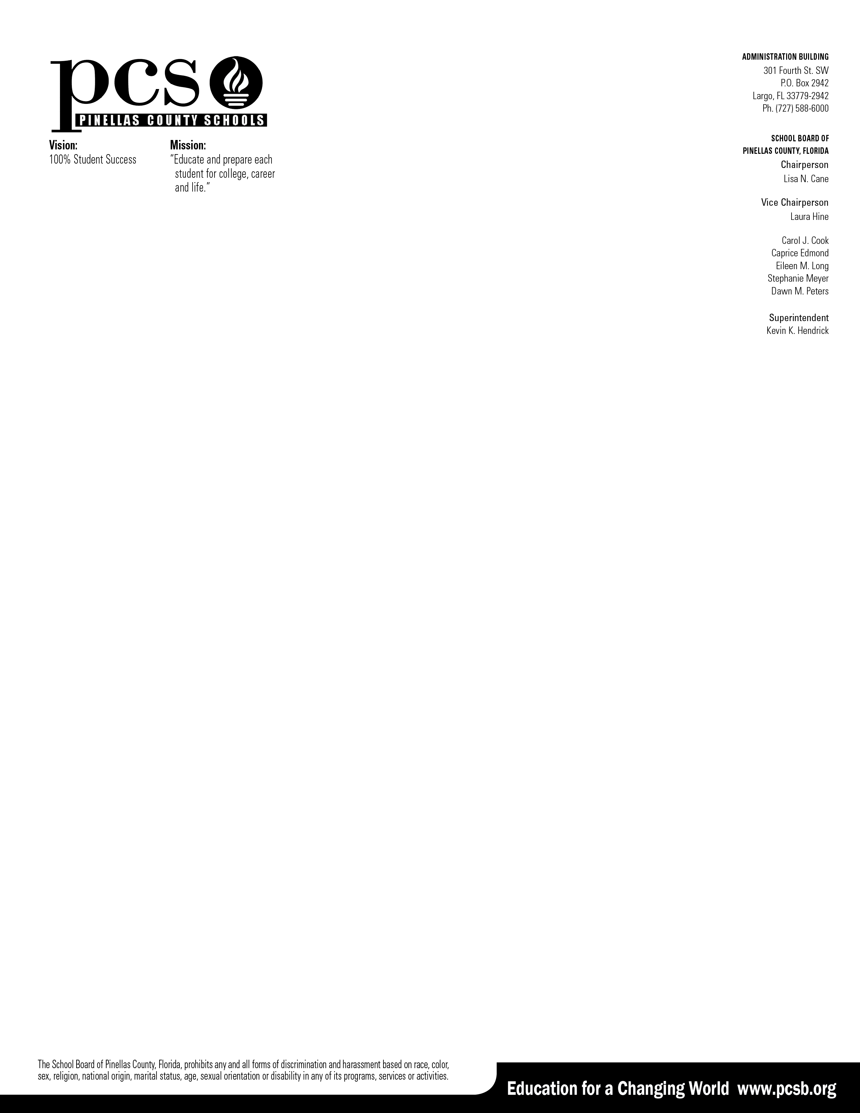

April 4, 2023

To Title I Families of Kindergarten thru Fifth Grade Students,

We are thrilled to announce the Kids Read Now summer reading program to maintain reading skills over the summer. Kids Read Now is a non-profit organization who designed a program to include best practices for reading engagement and growth. We are delighted to partner with this group to provide a high-quality reading program throughout the summer. The program is completely FREE to you and made possible through Title I funds.

Your child will choose eight books at their reading/grade level. The first book will be delivered to your child’s school in May, along with a Parent Guide, and then the remaining books will be mailed to your house throughout the summer.

To have the books arrive by mail during the summer basic information such as student and parent name, address, phone number, and email is needed by Kids Read Now. Kids Read Now only uses your contact information to send you books and send reminder messages.

If you would like your child to participate in this FREE program and receive the eight, new free books, either use the link or scan the QR code below to opt-in, by April 25th. The information on the form will be sent directly to Kids Read Now.

We look forward to your participation in the Kids Read Now summer reading program.

Most Sincerely,

Crystal Boyd

Title I Grant Coordinator

Sign-up link: [https://zfrmz.com/YsAxUXWDQbxfhVbrP8UC](https://nam11.safelinks.protection.outlook.com/?url=https%3A%2F%2Fzfrmz.com%2FYsAxUXWDQbxfhVbrP8UC&data=05%7C01%7Csheila.schurman%40kidsreadnow.org%7Cc9113821c00b4edf795008db2fbc4371%7Cdee13a4815234dfbb7296b7c91a86612%7C0%7C0%7C638156257878338744%7CUnknown%7CTWFpbGZsb3d8eyJWIjoiMC4wLjAwMDAiLCJQIjoiV2luMzIiLCJBTiI6Ik1haWwiLCJXVCI6Mn0%3D%7C3000%7C%7C%7C&sdata=qpqeUHQFsB0Cu9zJmLKKxgsQxLiNXpOhdjnY%2Fuewi%2BU%3D&reserved=0)

